Student’s Name
Professor’s name
Course code and name
Institutional affiliation
Date
Dred Scott vs Shelby
The Supreme case, Dred v Shelby, assists people in understanding unfair legal systems at that time. The apex courts the case and ruled in favor of the defendant killing the only hope that the black Americans had to end slavery. The decision meant that Shelby was able to continue enslaving the black Americas (Herda, 1). It also meant that there would be no negro of the Africans blood would ever be recognized as an American Citizen. The role of African Americans was to serve their masters for the rest of their lives unless the law was altered in their highly unlikely favor.
The Supreme Court decision also invalidated the compromise act of 1820. Some efforts would strike a balance of power in the congress between slaves as well as the frees state. The objective of the Missouri compromise Act allowed recognition of the Missouri Act as a slave state, while Maine was regarded as a free state. However, the agreement was repealed by the Kansas-Nebraska Act in 1854. The fact that Maine was allowed as a state in the United States as a free state explicitly elaborates that at the end of the tunnel, there exists some light. The act also prescribed that the slave trade from the remaining Louisiana Purchase lands north of the 36º and 30’ parallel was effectively banned.
On 6th March 1857, he described the landmark supreme ruling concerning Scott, a slave who had sued his master on several occasions and was not an American citizen. The Supreme Court decision is the final since the apex court on land in the United States. Consequently, once a decision has been reached, no revocation through an appeal can occur unless the change of law by the legislators. This is because the lower courts are required to follow the precedence set forthright by the supreme court on similar cases brought forward for determination.
There is a popular belief that black people in the modern United States are still affected by the legacy of slavery. It is evidenced by a recent study (figure 1) that illustrates a wide racial and partisan gap concerning the perspectives of slavery on the black American position in society. The black people argue that slavery has continued to impact: Over 59 % allude that the legacy of slavery affects the conditions of the black people in a very significant manner. Another 26 % of whites, 29 % of Hispanics and 33 % of Asians agree that slavery affects the position of black people in American society in the modern world very significantly. However, the majority of the groups believe the impact is a fair amount of play.
The survey also reveals that close to 45 % of the U.S. adults believe that the country has not gone far enough in granting equal rights to the whites. However, 15 % believe that it has gone too far while 39 % believes in the exact opposite and alludes it has been right. The United States is yet to make any significant progress on the issue of slavery according to 78 % of the black adults. It is in comparison with the 37 % of whites as well as 48 % of the Hispanics (Horowitz, 1).

Figure 1 survey on people's perceptions of the slavery issue in modern society.
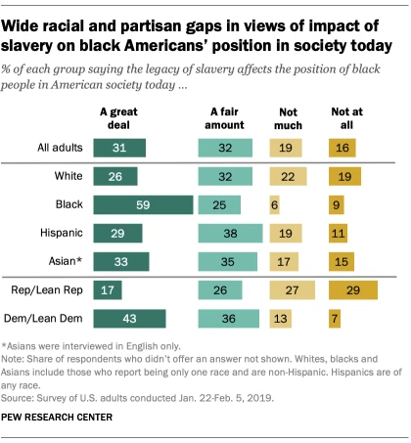
Source: https://www.pewresearch.org/fact-tank/2019/06/17/most-americans-say-the-legacy-of-slavery-still-affects-black-people-in-the-u-s-today/
There are some people's perceptions of the subject matter regarding the United states racial progress. Black people are a bit hesitant concerning the prospects of racial equality in the future. The majority of them allude that the country is far enough in granting black people equal rights alongside their white counterparts. 64 % indicated that the country is close to achieving racial equality. Close to 80 % of the whites are confident that at some point in the future black people and white people would have equal rights (Horowitz, 1).
Comparison of party-wise reveals that 80 % of the democrats and those who support its ideologies establish that are far more likely compared to 43 % of republicans and its supporters alludes that slavery still affects the situation of the black people in American society in the modern world. 66 % of the Democrats and 18 % of Republicans believe that the US is far from giving black people equal rights than whites. In another question of the survey, 28 % of the republicans suggested that the country was moving in the right direction and another 53 % states that it has been right all through. The party’s explanation reveals that it was time to advocate for the equal rights of black people (Horowitz, 1).
The relationship between black Americans and white Americans or other racial groups is going on a distinct path regarding the American racial as well as the ethnic politics in the American future. However, the key concern among the black community has always been how the relationship is based on material success as well as attachment to American policy. It is because increasing the complexities of the ethnic as well as racial coalitions and ethnic related policy issues would derail the African – American political behavior. Although there is the existence of clear patterns in both areas, the present patterns tend to be highly politically charged hence highly volatile as well as depict contingence on numerous people’s choices.
Black people should be treated more equally firm a legal standpoint in American society. The issue of sovereignty and recognition of rights for all people, regardless of color, race, and gender, illustrates the journey traversed to bring about sanity in the United States. The 1965 Voting Rights Act brought adept of the discriminatory practices in US history. The Act's developers wanted state officials to come up with ways that would keep minority voters away from the polls. For instance, the preclearance issue brought legal tussles thereby delaying the implementation of the changes instead of outright revocation. To ensure that black people enjoy equal rights as their white counterparts there is a need to preserve some seats on the table for black people. The seats would ensure that more blacks are in positions of power like their white counterparts.
The court system should outright ensure that equality is served to the people without any form of bias. The fact that Scott and his family were enslaved, despite looking for assistance from the corridors of justice but was denied justice. This representation of the system can be corrupted to take away the rights of other people in society. Although the Missouri compromise of 1850 granted the couple some freedom from slavery, the Supreme Court opted to take it again by denial Scott who was the plaintiff, his appeal prayers. At that point, it meant that the slave owners were at liberty to enslave and engage in the slave trade. Scott took the case to the supreme court because he and the majority of other people often believe that the state's supreme court issues justices and corrects the conflicting issues in the law. Therefore, the decision to deny Scott and his family the right to freedom exemplified that the supreme court's increasingly stance in pro-slavery. Furthermore, it was perceived as an opportunity to overturn the decisions of slaves that were agitated by slavery as well as those that had benefited the slaves from seeking any form of justice in the county. The decision was purely based on the supremacy between the slave owners and slaves and their connections.
During the scot's supreme court ruling, five of the 9 justices came from the families that held slaves' families. This meant the majority decision would take precedence and uphold the Missouri Supreme Court, which is the appellant court. Conflict of interest and unequal representation in the corridors of justice played a role in the Scot v Shelby decision. Consequently, there is a need to develop laws based on the conflict of interest where the interested parties to the issues are lawfully prevented from hearing to the matters. For instance, in this case, the five justices should not have participated in the judgment since their verdicts were already known as they could not rule against their families who were slave owners.
Black people are making tremendous progress in the political space in the modern world. This is illustrated by the fact a black American president was elected to the realm office. President Obama became the first president to betting all odds. Obama's stance represented a steady but slow stance for black people's space in the political sphere. In recent decades, the black is gaining greater footage of their political leadership, especially in the US house of representatives and the cabinets of recent presidents. However, they have lagged into senate and governorship positions (Carter, Prudence and Sean 1).
2016 Pew Research suggests the majority of blacks often perceive political representation as a catalyst for increased racial equality. About 38 % of black adults believe that working to get more black people elected to the office is the most effective strategy to sort out assist black people to attain the equality status they are seeking. However, 24 % of the whites were skeptical about this measure to bring racial inequality in the United States down. Therefore, they need to increase more seats to the black people through elections or nominations that would towards eliminating discriminatory policies while drafting policies that cater for the rights of people regardless of the race. Figure 2 below represents the number of black representatives elected into the political space in the United States.
Figure 2: Black US house members from 1965 to 2019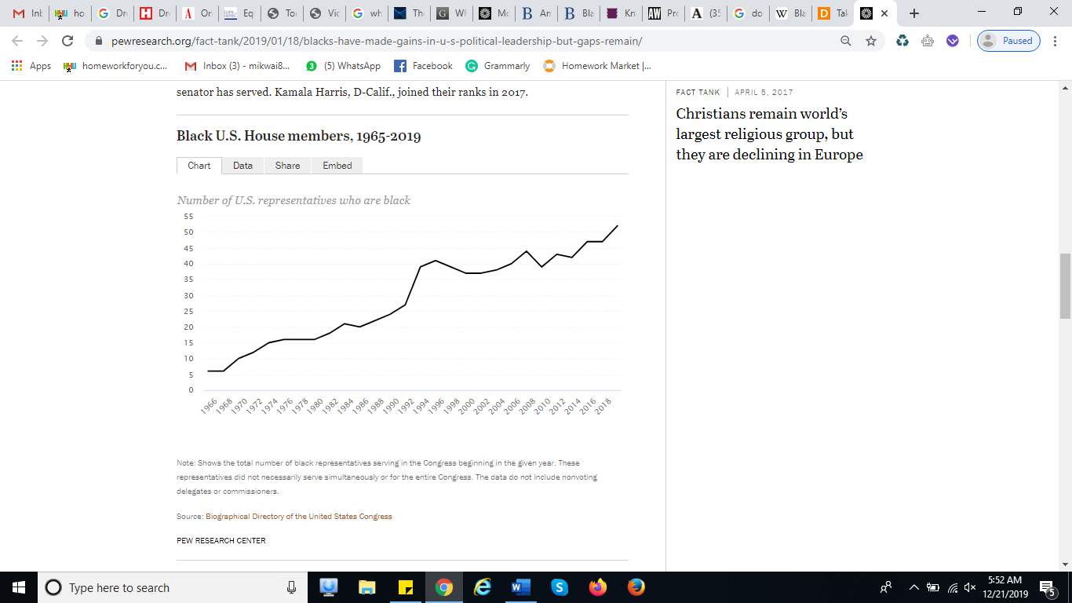
Source: https://www.pewresearch.org/fact-tank/2019/01/18/blacks-have-made-gains-in-u-s-political-leadership-but-gaps-remain/
In the economic space, labor issues culminated and evidenced by numerous worker's strikes point out that there exist some challenges. In April 1968, Martin Luther King was assassinated, barred because he was fighting for ongoing inequality in the county. There were numerous riots in the cities within the country over the tragedy that had befallen the hero. The Civil Rights Act of 1968 was also signed into law whose role was to end housing discriminations against the black people (Pepper, 1).
Furthermore, in 1968, the Kerner commission also delivered a report titled “white racism” to president Johnson exploring the causes of civil unrest in African-American communities. Some of the issues suggested were dealing with pervasive discrimination on the issues of employment, education, and housing. It also collected comprehensive data addressing specific issues concerning the economy as well as social inequalities that confront African Americans since 1968.
The Kerner report laid the stage for improvements in economic status if black people are in it. Since the report was released 50 years ago, there is clear good news as well as bad news. For instance, black Americans are economically better off compared to 1968 when the report was delivered to the president (Gooden and Myers, 12).
African Americans in the modern world are better educated compared to their historical beginnings, though they lag as far as overall education achievement is concerned. Close to 90 % of the younger generation of African Americans aged between 25 to 29 years are gradians describing the social progress the country has gone through.
In conclusion, the pace for success among African Americans is set. This is evidenced by the tremendous rise in political, economic and social space in the country. Although some hurdles may exist preventing full realization there is a high chance that equality would be attained at some point. There is a need to eradicate policies, ensure justice based on ideas and legislate laws that would grant equal opportunities to all citizens of America.

Work Cited
Carter, Prudence L., and Sean F. Reardon. "Inequality matters." William T. Grant Foundation Paper, New York: William T. Grant Foundation (2014).
Gooden, Susan T., and Samuel L. Myers. "The Kerner Commission Report Fifty Years Later: Revisiting the American Dream." RSF: The Russell Sage Foundation Journal of the Social Sciences 4.6 (2018): 1-17.
Herda, D. J. Slavery and Citizenship: The Dred Scott Case. Enslow Publishing, LLC, 2016.
Horowitz, J. Menace. Most Americans say the legacy of slavery still affects black people in the U.S. today. Pew Research Centre. (JUNE 17, 2019).Retrieved from: https://www.pewresearch.org/fact-tank/2019/06/17/most-americans-say-the-legacy-of-slavery-still-affects-black-people-in-the-u-s-today/
Pepper, William F. Orders to Kill: The Truth Behind the Murder of Martin Luther King. Skyhorse Publishing, Inc., 2015.

